**Budgeting Guide**:

The first thing that you should know is that your budget is always "working" meaning that it is just guess work, especially the first few months of application. Additionally, your budget is very individualized and what is listed here as examples may not exactly meet your needs, and that's okay! When putting your budget together make sure to give it some thought, it can be easy to leave things out.

1. Log in to Everydollar.com.

You must make an account. It is free to do you just need a working email to verify.

2. Calculate how much money you make *after* taxes and add it to the "income" section at the top of the page.

Include any income i.e., side-jobs, tips, money from your parents etc.

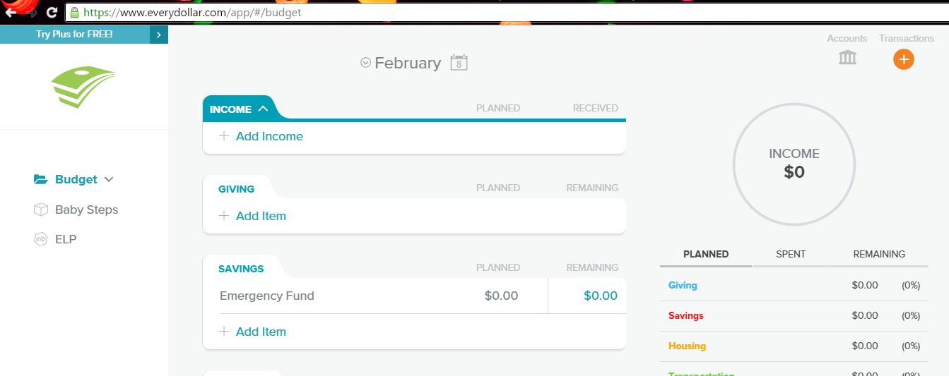

This is the homepage, you can start by clicking the addition button and add different categories for each section.

3. Calculate your expenses.

Everydollar.com separates expenses into categories:

Giving  
Savings  
Housing   
Transportation   
Food  
Lifestyle  
Insurance & Tax  
and Debt

4. Define the basic categories of your budget (based on your expenses, keep in mind that these can change month-to-month and so should your budget.)

Since everydollar.com already has these defined you can use them as they are or you can personalize them (shown below). It is important to remember to budget for basic needs first though. Always make sure housing and food costs are covered before moving on.   
  
The nice part about everydollar.com is that it lets you re-order the groups, so that you can put what is most important to you first. Another feature you can use is re-naming the categories to be more suited to your liking. 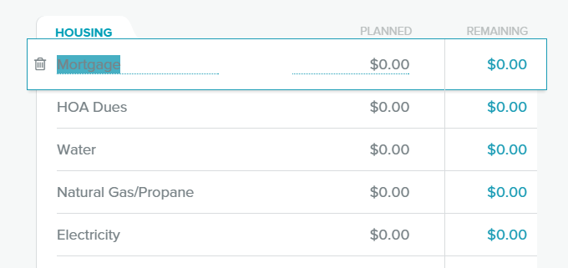

This is the pre-established 'housing' section, to re-name a category you can double click and it become highlighted, you can then type in whatever you want. If you would like to delete a category you just have to click the trashcan on the left.

5. List all your spending for each category.

Note here that you can denote your spending in weekly or monthly amounts, it's whatever works best for you and will also depend on how well you keep track of how well you're sticking to your budget.

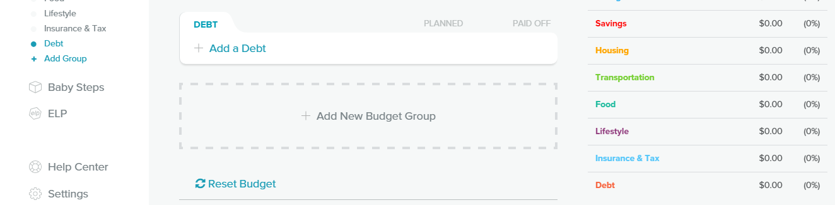If you scroll down to the bottom of the page you can add a new budget group if you like. Also, you can reset your entire budget.   
  
6. Now add up all your spending categories, again if you're not sure about a category save your receipts for a month and this will give you a good starting number. The total you get here is your monthly spending. Now compare it to step one, your total income after taxes.

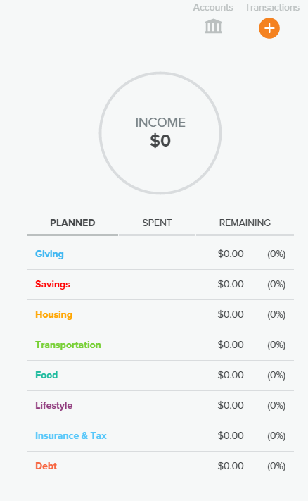

This section will always be on the right side of the screen. It will keep running totals for each of your groups. You can also manually enter recent transactions using the orange plus button in the right hand corner.

7. Make sure to set goals for yourself to make sure you're sticking to your budget.

Why are you going on a budget?   
-To save for college?   
-To get out of debt?

Side note: To get a bigger picture, you can highlight look through each month by using the calendar at the top of the page.

